**CST-350 Project Status and Design Report**

**.NET Application Programming**

|  |  |  |
| --- | --- | --- |
| **Topic:** | Topic 8: ASP.NET LINQ And Lambda | |
| **Date:** | *06/25/2023* | |
| **Revision:** | *1.4* | |
| **Team:** | 1. *Martin Carranza Alvarez* | |
| 1. *Raymond Lawson* | |
| 1. *Ryan Coon* | |
|  | |
| **Milestone Task Summary:** | |  |  |  |  | | --- | --- | --- | --- | | **User Story** | **Team**  **Member** | **Hours**  **Worked** | **Hours Remaining** | | *Project planning and task discussions* | *Everyone* | *1* | *0* | | *Topic and Research* | *Everyone* | *1* | *0* | | *Code refactoring, cleanup, and commenting* | *Martin and Raymond* | *2* | *0* | | *Adding logging to the application* | *Ryan and Raymond* | *4* | *0* | | *Implemented HTTP Request Filter* | *Martin and Ryan* | *3* | *0* | | *Debugging new errors from changes to app* | *Everyone* | *1* | *0* | | *DB ER, Sitemap, Wireframe, flowchart, and UML Class Diagrams updates* | *Raymond* | *1.5* | *0* | | [Loom Video](https://www.loom.com/share/ff6a16e8e2d74b4abf522c5e3b7cb2da) | *Raymond* | *0.5* | *0* | |  |  |  |  | |  |  |  |  | | |
| **Repository URL:** | <https://github.com/btzblackout/CLC350> | |
| **Peer Review:** | *Yes* | We acknowledge that our team has reviewed this report and we agree to the approach we are all taking. |

**Planning Documentation**

**Agile Scrum Product Backlog: (ALL LOCATED UNDER SCUM FOLDER)**

*This needs to contain a URL to a Scrum Product Backlog for the entire application scope.*

<https://github.com/btzblackout/CLC350/tree/main/Design%20Document%20%2B%20Scrum>

**Agile Scrum Sprint Backlog:**

*This needs to contain a URL to Scrum Sprint Backlog.*

<https://github.com/btzblackout/CLC350/tree/main/Design%20Document%20%2B%20Scrum>

**Agile Scrum Burn Down Chart:**

*This needs to contain a URL to a Scrum Burn Down Chart.*

<https://github.com/btzblackout/CLC350/tree/main/Design%20Document%20%2B%20Scrum>

**Agile Retrospective Results:**

*The following table should be completed after each Retrospective on things that went well (keep doing).*

|  |
| --- |
| **What Went Well** |
| Refactoring, cleaning, and commenting code. |
| Implementing logging system. |
| Utilized HTTP Request filter. |

*The following table should be completed after each Retrospective on things that didn’t go well (stop doing) and what would be done differently next time. An Action Plan is a short statement describing what you will do differently. The due date for the plan is when you will implement the change.*

|  |  |  |
| --- | --- | --- |
| **What Did Not Go Well** | **Action Plan** | **Due Date** |
| Had issues implementing the load game function due to not knowing early on that we would be required to have multiple games per user. We created the app with the intention to only have one game per user so we are running into issue loading in a new grid. Will need to redo a lot models and code to get this to work. | Next week will need to redo a lot of the code to get the load new game function to work. | N/A |
|  |  |  |
|  |  |  |

**Design Documentation**

**Install Instructions:**

*Step-by-step instructions for setting up your database and configuring, and deploying/installing your application. This section should also include detailed instructions for what configuration files are required by your application, what configuration settings need to be adjusted for various runtime (development or production) environments, and where the files need to be deployed to.*

1. *Download Visual Studio*
2. *Got to provided GitHub Link and copy link to close repo*
3. *Start VS and click on clone repo, use the link and paste it where required and click continue.  
   Project will now be loaded.*
4. *First before you launch the project you will need to create a new Database, you can name it as you please, and inside that database you will need to create a table called ‘users’, ‘cells’, ‘grids’, and ‘SavedGames’. Feel free to use the DDL Script to create this table.*
5. *Please make sure you also update your connections string inside the DAO files.*
6. *Start the project and try it for yourself!*

**Key Technical Design Decisions:**

*Any final technical design decisions, such as framework decisions, addressing its purpose in the design and why it was chosen.*

The key technical decisions for the minesweeper web app include using Visual Studios MVC web app framework and its built in SQL database. The main focus of the project is functionality over aesthetics. This meaning the app will be functional before it’s made pretty later on. This approach is taken to ensure the app works as intended before moving on to improve its visual design.

**ER Diagram:**

*The ER diagram shows the design of database tables and foreign key relationships. Include an image file of your ER database diagram.*

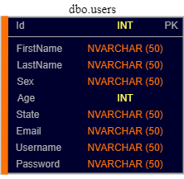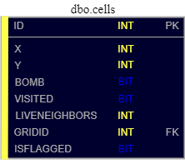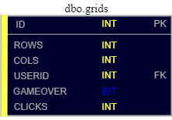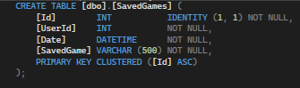

**DDL Scripts:**

CREATE TABLE [dbo].[users] (

[Id] INT IDENTITY(1,1) NOT NULL,

[FirstName] NVARCHAR (50) NOT NULL,

[LastName] NVARCHAR (50) NOT NULL,

[Sex] NVARCHAR (50) NOT NULL,

[Age] INT NOT NULL,

[State] NVARCHAR (50) NOT NULL,

[Email] NVARCHAR (50) NOT NULL,

[Username] NVARCHAR (50) NOT NULL,

[Password] NVARCHAR (50) NOT NULL,

CONSTRAINT PK_users PRIMARY KEY (Id)

);

// cells table

CREATE TABLE [dbo].[cells] (

[ID] INT IDENTITY (1, 1) NOT NULL,

[X] INT NOT NULL,

[Y] INT NOT NULL,

[BOMB] BIT NOT NULL,

[VISITED] BIT NOT NULL,

[LIVENEIGHBORS] INT NOT NULL,

[GRIDID] INT NOT NULL,

[ISFLAGGED] BIT NOT NULL,

PRIMARY KEY CLUSTERED ([ID] ASC)

);

// Grid table

CREATE TABLE [dbo].[grids] (

[ID] INT IDENTITY (1, 1) NOT NULL,

[ROWS] INT NOT NULL,

[COLS] INT NOT NULL,

[USERID] INT NOT NULL,

[GAMEOVER] BIT NOT NULL,

[CLICKS] INT NULL,

PRIMARY KEY CLUSTERED ([ID] ASC)

);

CREATE TABLE [dbo].[SavedGames] (

[Id] INT IDENTITY (1, 1) NOT NULL,

[UserId] INT NOT NULL,

[Date] DATETIME NOT NULL,

[SavedGame] VARCHAR (500) NOT NULL,

PRIMARY KEY CLUSTERED ([Id] ASC)

);

**Sitemap Diagram:**

*The Sitemap shows a navigation path that the user can take through the application. Include an image file of your Sitemap diagram.*

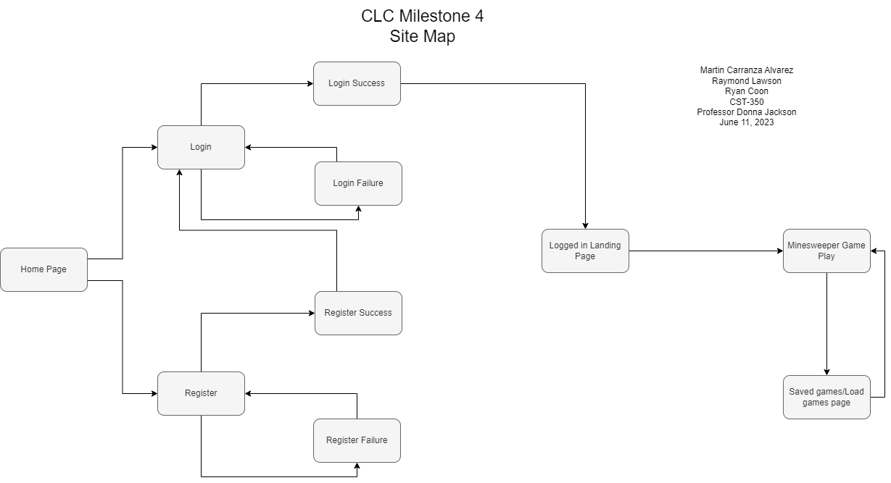

**Security Design:**

*This section should outline the design for how authentication and authorization was supported. This section should also contain all of the roles and privileges that are supported by the design.*There is currently basic authentication established via the base SecurityDOA file. The file will create users and then when a user is trying to login it will confirm if the user exists and if the credentials are correct. We could later further increase security by making it so that if a user is trying to register and they already have an account with the same email, username, or phone they will get denied registration and told the already have an account. 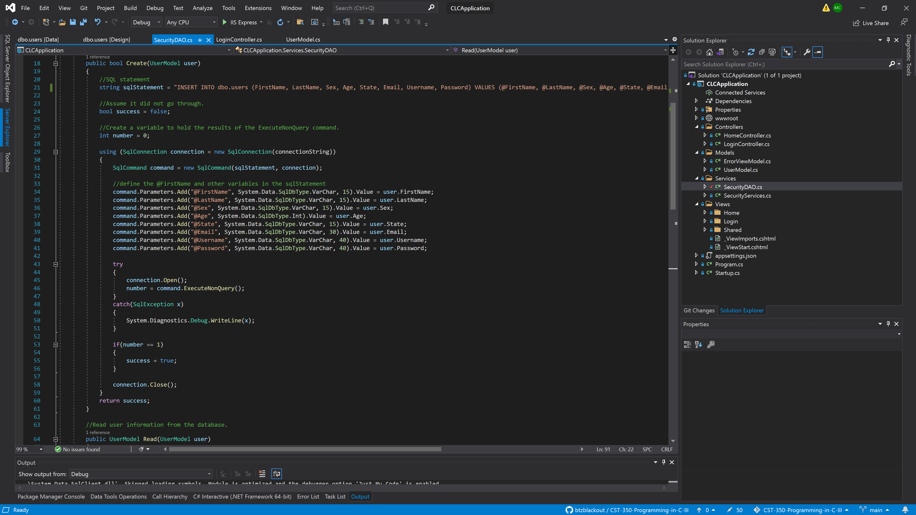

**Third Part Interface Design:**

*This section should fully document any Third Party Service Interface API’s, how to access the service, what parameters are required by the API, and the detailed JSON data format specification that could be used by a third party developer to integrate with the service and API.*

*Not due this week* or N/A

**Flow Charts:**

*You should insert any flow charts here. Flow charts should document algorithms or workflow that will be implemented in your program. At a minimum, this should contain a flow chart of the Minesweeper game logic.*

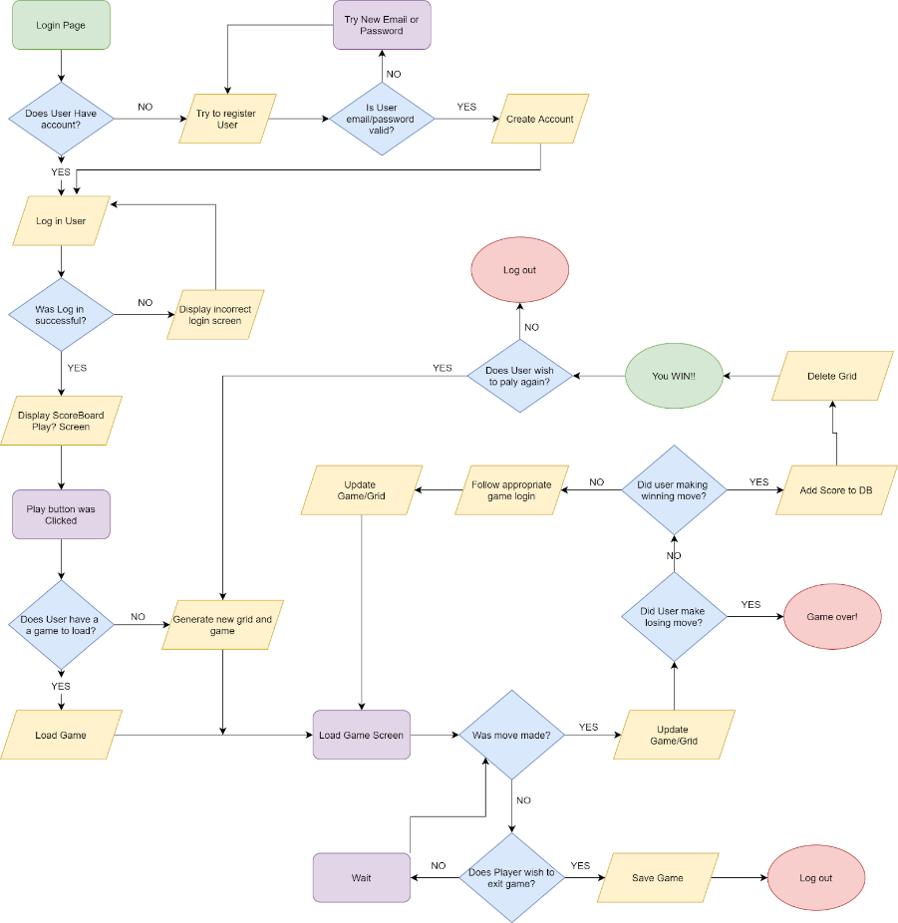

**User Interface Diagrams:**

*You should insert any wireframe drawings or whiteboard concepts that were developed to support your application.*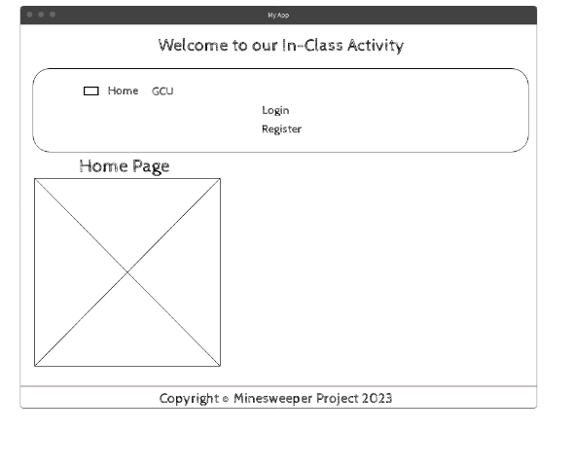 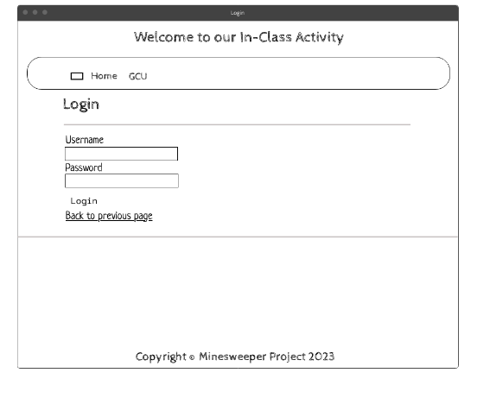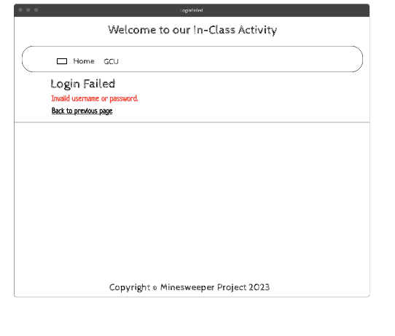

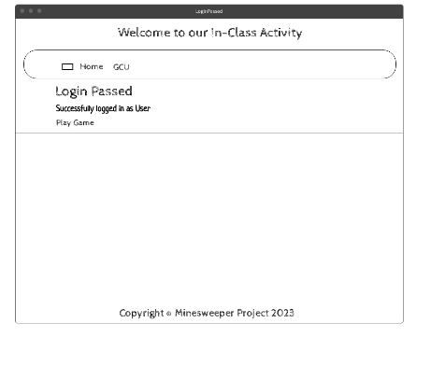 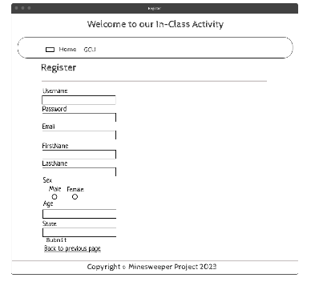 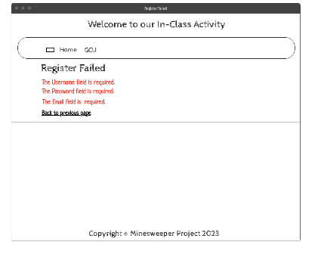

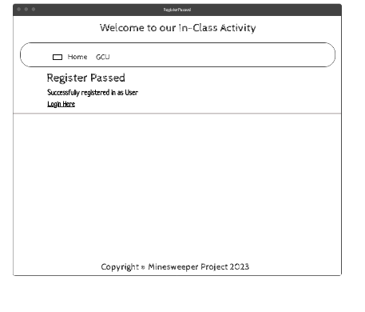 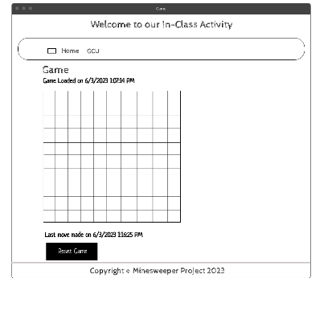

**Class Diagrams:**

*You should insert any class diagrams here. Your class diagrams should be drawn correctly with the three appropriate class compartments, + and – minus to indicate accessibility, and the data types for the state/properties, as well as method arguments and return types.*

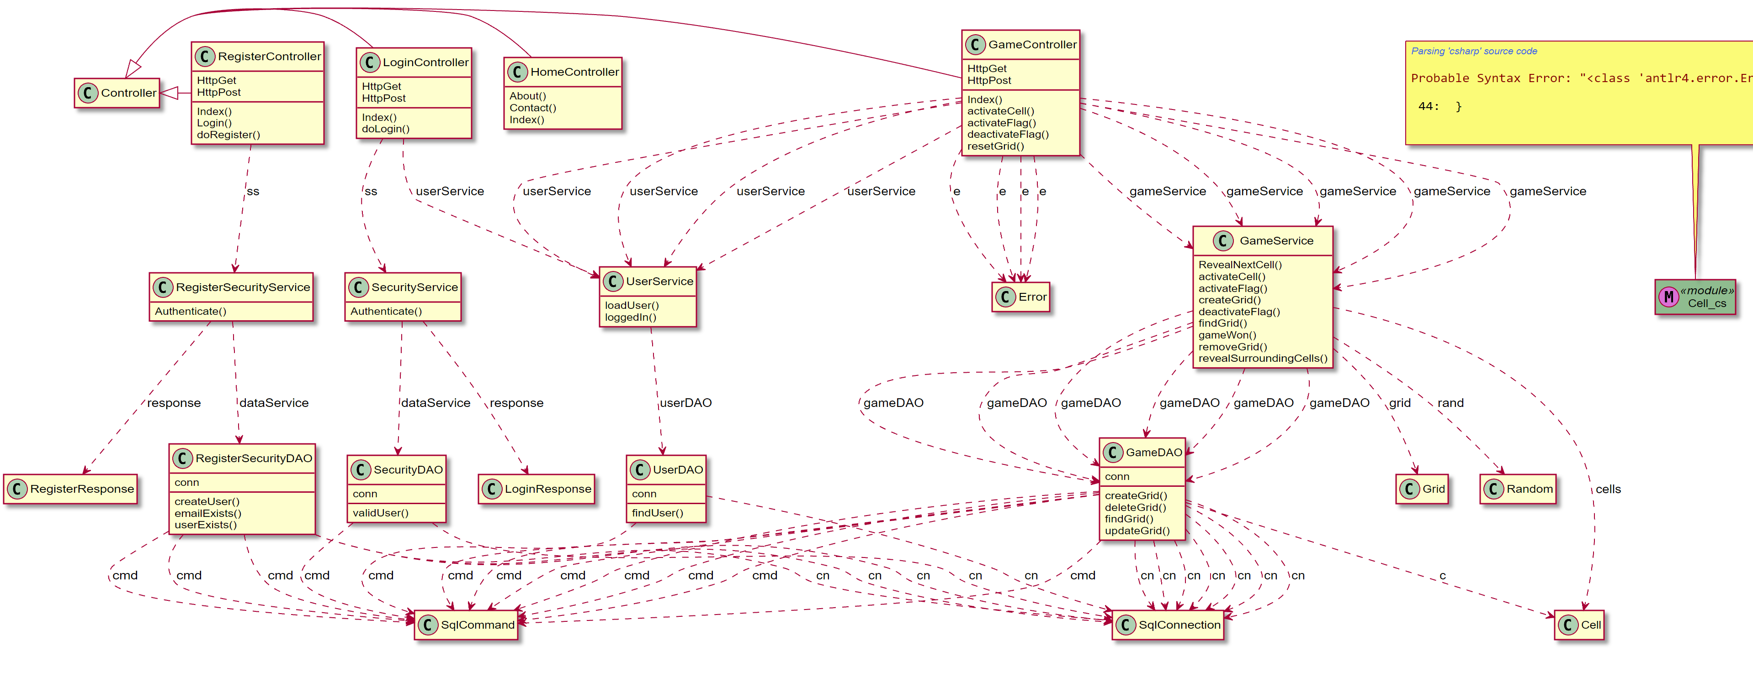

**Pseudo Code:**

*You should provide a URL references to any code stubs and pseudocode. If you have no supporting documentation, please explain the rationale for why you are able to leave this section as N/A.  
N/A*

**Other Documentation:**

*You should insert any additional drawings, storyboards, whiteboard pictures, project schedules, tasks lists, etc. that support your approach, design, and project. If you have no supporting documentation, please explain the rationale for why you are able to leave this section as N/A.  
  
 Loom Video Demo --* <https://www.loom.com/share/ff6a16e8e2d74b4abf522c5e3b7cb2da>